Bangladesh Medical Association (BMA)
List of Life Member-47
11. BMA Chuadanga Branch

Sl No | Voter No | Voter Details
1 | Voter No  LM-1100001  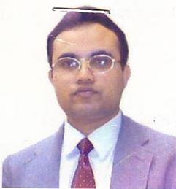 | DR. MD. BASIRUL AZAM  F/Name: Abdul Kabir  M/Name: Porejun Nessa  BM & DC Reg. No: 22269  NID:  Cell: 01712671040  Address: a  Blood Group:
2 | Voter No  LM-1100002  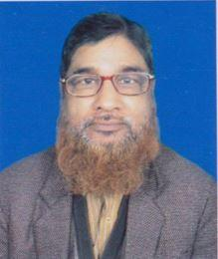 | DR. MD. ALAUDDIN AL AZAD  F/Name: Late Moniruddin Mollah  M/Name: Late Moytan Nessa  BM & DC Reg. No: 10720  NID:  Cell: 01711988364  Address: Hospital Road,, Chuadanga  Blood Group:
3 | Voter No  LM-1100003  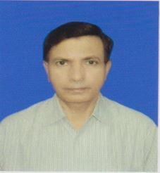 | DR. MD. NAZIMUDDIN KHAN  F/Name: Late Daliluddin Khan  M/Name: Late Khabirun Nessa  BM & DC Reg. No: 9749  NID:  Cell: 01711309672  Address: Cowetpara, Chuadanga.  Blood Group: A+
4 | Voter No  LM-1100004  No Image | DR. MD. MASUDUR RAHMAN  F/Name: Md. Mahabubur Rahman  M/Name:  BM & DC Reg. No:  NID:  Cell:  Address: Junior Consaltant T.B Clinic, Chuadanga.  Blood Group:
5 | Voter No  LM-1100005  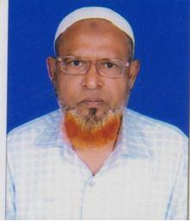 | DR. MD. KHABIR UDDIN  F/Name: Late Baser Ali  M/Name: Late Nessor Bibi  BM & DC Reg. No:  NID:  Cell: 01712172370  Address: Hospital Roa, Chuadanga  Blood Group:
6 | Voter No  LM-1100006  No Image | DR. Z.H.M. WAHID ASHRAF DELWAR  F/Name: Late Khejmat Ali  M/Name:  BM & DC Reg. No:  NID:  Cell:  Address: 40, Emergency Road, Chuadanga.  Blood Group:  E X P I R E D
7 | Voter No  LM-1100007  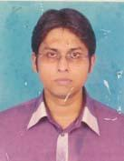 | DR. A.K.M TANVIRUL HAQUE  F/Name: Md. Rezaul Haque  M/Name: Mrs. Lutfunnessa  BM & DC Reg. No: 47747  NID: 1822309173982  Cell: 01715153845  Address: Thikana Building, Hospital Road, Chuadanga  Blood Group: O+
8 | Voter No  LM-1100008  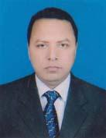 | DR. PARITTOSH KUMAR GHOSH  F/Name: Gour Chandra Ghosh  M/Name: Loxmi Rani Ghosh  BM & DC Reg. No: 22850  NID: 1822309168892  Cell: 01712100550  Address: Thikana Bhabon, Hospital Road, Chuadanga  Blood Group: O+
9 | Voter No  LM-1100009  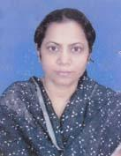 | DR. HOSNA ZARY TAHMINA  F/Name: Md. Shohorab Uddin  M/Name: Mst. Hamida Khatun  BM & DC Reg. No: 23535  NID: 1823103305029  Cell: 01716446252  Address: Sadar Upzila, Chuadanga.  Blood Group: A+
10 | Voter No  LM-1100010  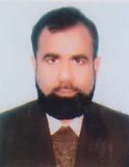 | DR. MD. SAYED-UR RAHMAN  F/Name: Md. Islam Ali Mondol  M/Name: Mrs. Fatema Khatun  BM & DC Reg. No: 13292  NID: 1822309169969  Cell: 01715857462  Address: Hospital Road Chuadanga  Blood Group: B+
11 | Voter No  LM-1100011 | DR. ABU BAKAR SIDDIQUE  F/Name: Md. Abul Kashem (late)  M/Name: Akhter Banu  BM & DC Reg. No: 20581  NID: 2694814970010  Cell: 01715040535  Address: Chuadanga Sadar Hospital, Chuadanga  Blood Group: B+
12 | Voter No  LM-1100012  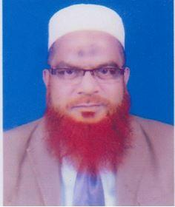 | DR. EKRAMUL HOQUE  F/Name: Late Yakub Ali Mondal  M/Name: Late Rizia Khatun  BM & DC Reg. No: 8706  NID:  Cell: 01715040535  Address: "Bipasha Bhaban" Cinema Hall Para, Hospital Road, Chuadanga.  Blood Group:
13 | Voter No  LM-1100013  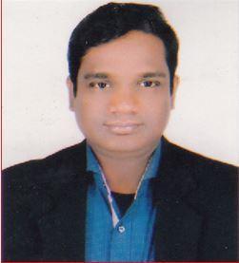 | DR. MD. AULIAR RAHMAN  F/Name: Md. Maynuddin  M/Name: Asia Khatun  BM & DC Reg. No: 44948  NID:  Cell: 01718529775  Address: Vill & P.O. : Dingadah, Upazilla & Zilla : Chuadanga.  Blood Group:
14 | Voter No  LM-1100014  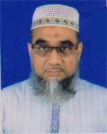 | DR. FAKIR MOHAMMED  F/Name: Late. Md. Mojibur Rahman  M/Name: Late. Most. Sajeda Khatun  BM & DC Reg. No: 16521  NID: 1822309170277  Cell: 01719338511  Address: Chuadanga Chokkhu Clinic, Hospital Road, Chuadanga  Blood Group: O+
15 | Voter No  LM-1100015  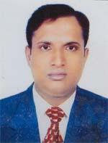 | DR. MD. RAFIQUL ISLAM  F/Name: Md. Sherajul Islam  M/Name: Mrs. Monowara Khatun  BM & DC Reg. No: 34680  NID: 1812323271923  Cell: 01716115507  Address: Jun. Consultant. UHC, Jibonnagar, Chuadanga  Blood Group: AB+
16 | Voter No  LM-1100016  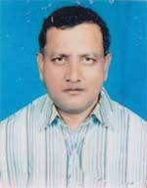 | DR. MD. TARIKUL ALAM  F/Name: Late. Fakir Ahmed  M/Name: Late. Sayakulu Khatun  BM & DC Reg. No: 18591  NID: 1823103305028  Cell: 01815300840  Address: Darshana, Chuadanga  Blood Group: B+
17 | Voter No  LM-1100017  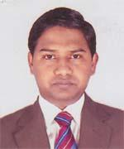 | DR. MD. SOUD KABIR MALIK  F/Name: MD. HUMAYUN KABIR MALIK  M/Name: MOST. ANGKHIZA KHATUN  BM & DC Reg. No: 50270  NID: 1822305143338  Cell: 01711423871  Address: Kutubpur Union Sub Centre, Sadar, Chuadanga  Blood Group: O+
18 | Voter No  LM-1100018 | DR. BUDHADIPTA DAS  F/Name: Dino Bandhu Das  M/Name: Chandra Bali Das  BM & DC Reg. No: 50835  NID: 8198510364699  Cell: 01717-622707  Address: Miapara, Alamdanga, Chuadanga  Blood Group: A+
19 | Voter No  LM-1100019  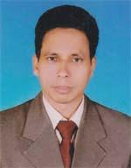 | DR. MD. HABIBUR RAHMAN  F/Name: Harej Uddin  M/Name: Monowara Khatun  BM & DC Reg. No: 36924  NID: 1812371220458  Cell: 01712086469  Address: Vill: Jaforpur, Post+P.S+Dist: Chuadanga  Blood Group: B+
20 | Voter No  LM-1100020 | MD. ASIF IQBAL  F/Name: Md. Sayed Ur Rahman  M/Name: Mosammat Bilkis Jahan  BM & DC Reg. No: 72145  NID: 391947686316  Cell: 01730039916  Address: 184, Eye Hospital Road, Chuadanga.  Blood Group: B+
21 | Voter No  LM-1100021  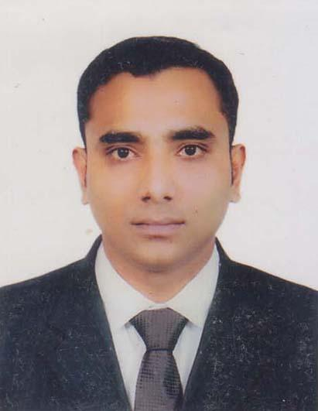 | DR. MD. AL IMRAN JEWEL  F/Name: Md. Habidur Rahman  M/Name: Mst. Nazmun Nahar  BM & DC Reg. No: 65865  NID: 1812371222545  Cell: 01715447624  Address: House-67, Road-51B, Block-E, Hospital, Thana council Para, chuadanga.  Blood Group: O+
22 | Voter No  LM-1100022  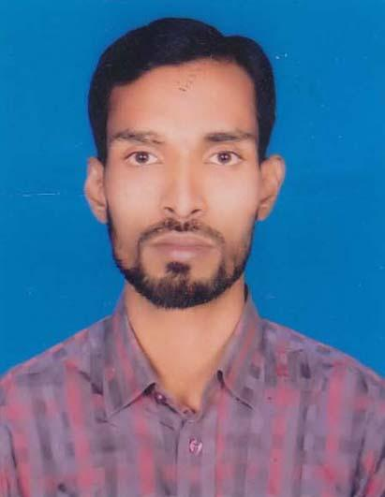 | DR. MD. MUNIR HASAN  F/Name: Md. Sunnat Ali  M/Name: Most. Rowshonara  BM & DC Reg. No: 71758  NID: 19901812323000058  Cell: 01882200101  Address: Vill: Hizolgari, P.O: Begumpur, P.S+Dist. Chuadanga.  Blood Group: O+
23 | Voter No  LM-1100023  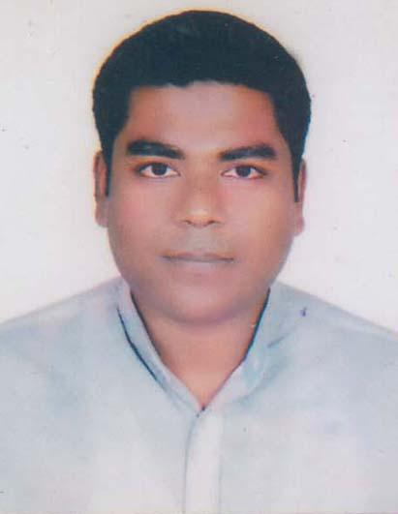 | DR. ABDULLA ALL NOMUN  F/Name: A.k.m. Arif  M/Name: Mst. Bilkis Ara  BM & DC Reg. No: 79737  NID: 19931822303000015  Cell: 01922727216  Address: Vill: Hizolgari, P.O: Begumpur, P.S+Dist. Chuadanga.  Blood Group: O+
24 | Voter No  LM-1100024  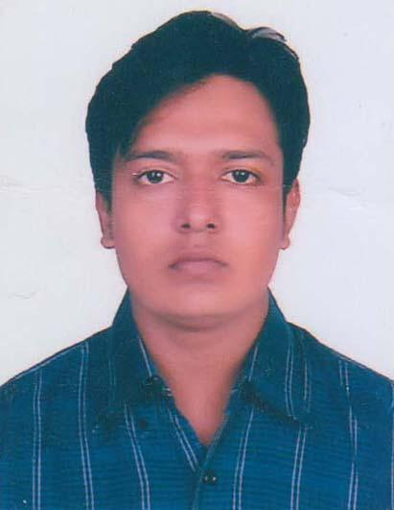 | DR. SAZID HASAN  F/Name: Md. Ebadat Hossain  M/Name: Nazma Akhter  BM & DC Reg. No: 78563  NID: 19911812347000010  Cell: 01712917830  Address: Vill: Jalebila, P.O: Surojganj P.S+Dist. Chuadanga.  Blood Group: B+
25 | Voter No  LM-1100025  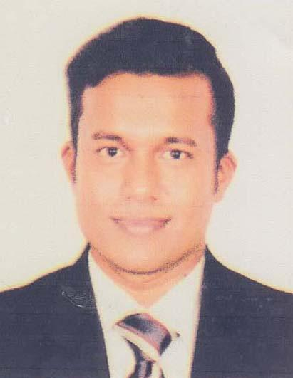 | DR. MD. SAMSUR RASID  F/Name: Md. Salah Uddin  M/Name: Mst. Kohinoor Akhter  BM & DC Reg. No: 80431  NID: 19921822309000001  Cell: 01714442855  Address: Mina Bari, Haque Para, Eidgah Road, Dist.Chuadanga.  Blood Group: B+
26 | Voter No  LM-1100026  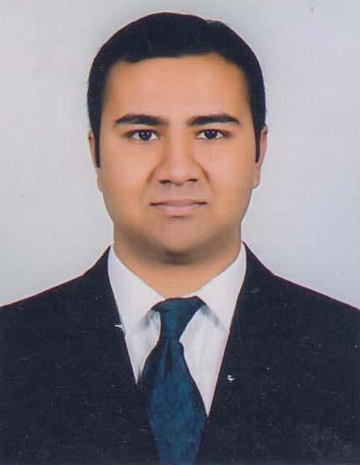 | DR. MARVIN ANIK CHOWDHURY  F/Name: Dr. Martin Hirak Chowdhury  M/Name: Sikha Chowdhury  BM & DC Reg. No: 78178  NID: 9567426680  Cell: 01727530282  Address: 168/6, Ground Floor, Green road, Dhaka.  Blood Group: O+
27 | Voter No  LM-1100027  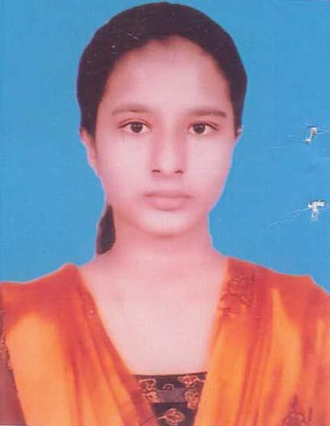 | DR. FATIMA HAQUE  F/Name: Md. Mofizul Haque  M/Name: Momena Khatun  BM & DC Reg. No: 75010  NID: 19924221905000080  Cell: 01758331234  Address: Vill: Zolibila, Post: Sorojgonj, Chuadanga.  Blood Group: A+
28 | Voter No  LM-1100028  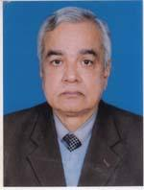 | DR. MARTIN HIRAK CHOWDHURY  F/Name: Sudhendu Prakas Chowdhury  M/Name: Ruth Shefali Chowdhury  BM & DC Reg. No: 7763  NID: 4650744396  Cell: 01711065340  Address: Goracs Cohage, Shahid Abul Kashem Sarak Chuadanga-7200. Chuadanga.  Blood Group: A+
29 | Voter No  LM-1100029  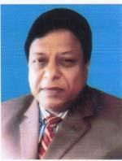 | DR. MD. ABDUL LATIF  F/Name: Late: Salar Uddin  M/Name: Late: Morzina Begum  BM & DC Reg. No: 14012  NID: 8250674820  Cell: 01712567863  Address: Eid-Ga-Para, Thana Counsi Road, Chuadanga.  Blood Group: AB+
30 | Voter No  LM-1100030  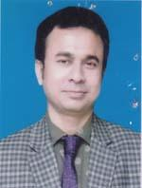 | DR. MD. SHYFULLAH  F/Name: Md. Motiar Rahman  M/Name: Hazera Khatun  BM & DC Reg. No: 43367  NID: 1810779751191  Cell: 01711184321  Address: Vill-Tiosbila, PO- Ailhash, PS- Alamdanga Dist- Chuadanga.  Blood Group: B+
31 | Voter No  LM-1100031  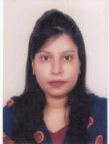 | DR. SOHANA AHMED  F/Name: Sultan Ahmed  M/Name: Sahanara Begum  BM & DC Reg. No: 72035  NID: 1906064546  Cell: 01786414200  Address: Mukti Para, Chuadanga.  Blood Group: A+
32 | Voter No  LM-1100032  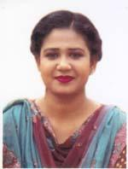 | DR. HUMAIRA NARGIS  F/Name: Md. Abdul Hannan  M/Name: Latifa Parvin  BM & DC Reg. No: 88486  NID: 1027701596  Cell: 01799492364  Address: Court Para, Chuadanga.  Blood Group: B+
33 | Voter No  LM-1100033  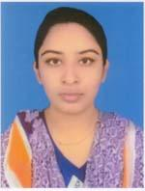 | DR. NAFISHA NOUSHIN  F/Name: Md. Ashraful Haq  M/Name: Mst. Shirajam Monira  BM & DC Reg. No: 95123  NID: 3728755038  Cell: 01710711644  Address: Hospital Road, College Para, Chuadanga.  Blood Group: O+
34 | Voter No  LM-1100034  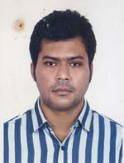 | DR. MD. NAZMUS SAKIB  F/Name: Md. Shahjahan Ali  M/Name: Sayeda Shahjahan  BM & DC Reg. No: 72854  NID: 1500696883  Cell: 01715848887  Address: Sheikh Para, Chuadanga Sadar, Chuadanga-7200.  Blood Group: O+
35 | Voter No  LM-1100035  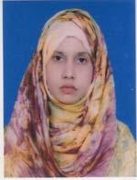 | DR. TOMANNAZ TASNIM  F/Name: Anis Uddin Biswas  M/Name: Zakia Naznin  BM & DC Reg. No: 72406  NID: 6853108071  Cell: 01925296063  Address: Cinema Hall Para, Chuadanga Sadar, Chuadanga.  Blood Group: B+
36 | Voter No  LM-1100036  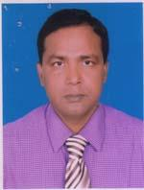 | DR. MD. SHAMIM KABIR  F/Name: Late: Ayub Ali Mullah  M/Name: Mst. Momena Khatun  BM & DC Reg. No: 35178  NID: 1812371222547  Cell: 01911309632  Address: Thana Council Para, Sadar Thana- Chuadanga.  Blood Group: B+
37 | Voter No  LM-1100037  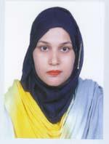 | DR. NUSRAT NAOREEN NAHER  F/Name: Md. Azizul Haque  M/Name: Mst. Nurur Nahar  BM & DC Reg. No: 74421  NID: 19911820701000017  Cell: 01747301907  Address: Hospital Road, Chuadanga.  Blood Group: B+
38 | Voter No  LM-1100038  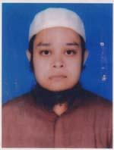 | DR. MD. SHIBLI SADEQUE  F/Name: Md. Hafizur Rahman  M/Name: Mrs. Khaleda Begum  BM & DC Reg. No: 69291  NID: 19872694812074751  Cell: 01763280066  Address: House No. 0839-01, Para, Cinemahall (053) Chokkhu Hospital Road.  Blood Group: B+
39 | Voter No  LM-1100039  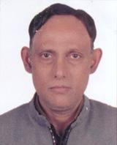 | DR. MUSTAK RAHMAN  F/Name: Late: Mustafizur Rahman  M/Name: Late: Selina Akhter  BM & DC Reg. No: 19779  NID: 7356370879  Cell: 01731997710  Address: Joardar Para, Badurtolla Chuadanga Sadar, Chuadanga.  Blood Group: B+
40 | Voter No  LM-1100040 | DR. MIZANUR RAHMAN  F/Name: Late: Somir Uddin Mollah  M/Name: Monju Ara Begum  BM & DC Reg. No: 34899  NID: 6000643384  Cell: 01719413299  Address: College Para, Chuadanga.  Blood Group: B+
41 | Voter No  LM-1100041  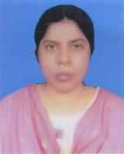 | DR. SHAHIDA KHATUN  F/Name: Late: Hares Uddin  M/Name: Sayeda Tanbirul Fatema  BM & DC Reg. No: 33146  NID: 8700569588  Cell: 01719304636  Address: House-5124-00. Cinama Hall Para. Hospital Road-Chuadanga.  Blood Group: B+
42 | Voter No  LM-1100042  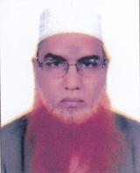 | DR. MD. ABUL HOSSAIN  F/Name: Anoz Ali  M/Name: Monjina Khatun  BM & DC Reg. No: 20527  NID: 6000633708  Cell: 01711184677  Address: Eye Hospital Road, Gulshanpara Chuadanga.  Blood Group: A+
43 | Voter No  LM-1100043 | DR. MD. MELONURZAMAN JOARDER  F/Name: Mohammad Ali Joarder  M/Name: Mrs. Shahida Khatun  BM & DC Reg. No: 49498  NID: 2850593795  Cell: 01721262878  Address: Sadar Hospital, Chuadanga.  Blood Group: A+
44 | Voter No  LM-1100044  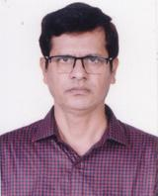 | DR. MD. BELAL UDDIN  F/Name: Md. Ruhul Amin  M/Name: Mst. Aharon Nesa  BM & DC Reg. No: 20223  NID: 4200581561  Cell: 01711479199  Address: Cinema Hall Para, Chuadanga.  Blood Group: B+
45 | Voter No  LM-1100045  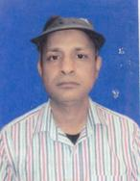 | DR. MUHAMMAD ZAKIR HOSSAIN  F/Name: Md. Arif Hossain  M/Name: Mrs. Momotaz Begum  BM & DC Reg. No: 27001  NID: 1822303130213  Cell: 01954881901  Address: Chuadanga, Mohila College Para.  Blood Group: B+
46 | Voter No  LM-1100046  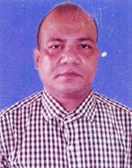 | DR. MD. ATAUR RAHMAN  F/Name: Md. Abdul Mannan Munshi  M/Name: Msd. Khorsida Begum  BM & DC Reg. No: 24223  NID: 5551092504  Cell: 01712687013  Address: UH & FPO, Sadar, Chuadanga.  Blood Group: AB+
47 | Voter No  LM-1100047  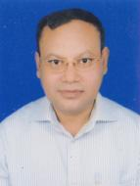 | DR. MD. SHAFIQUL ISLAM  F/Name: Dolil Uddin Biswas  M/Name: Mst. Monowara Begum  BM & DC Reg. No: 17665  NID: 7350632696  Cell: 01711394985  Address: Cinema Hall Para, Chuadanga-7200  Blood Group: B+

